Fariz Rinovada Naya
103062400007
S1-IT-KJ-24-004
“Tugas Praktikum Pemrograman Web Week 1”

STATUS
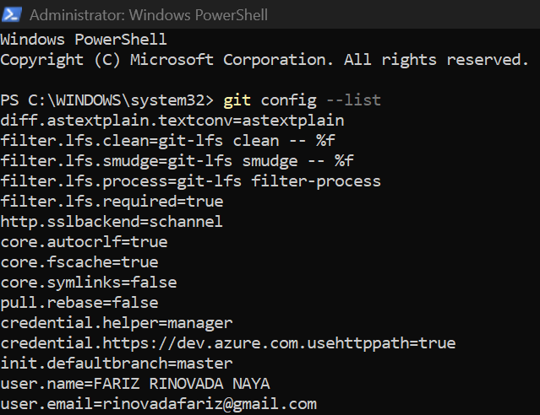

Riwayat Commit
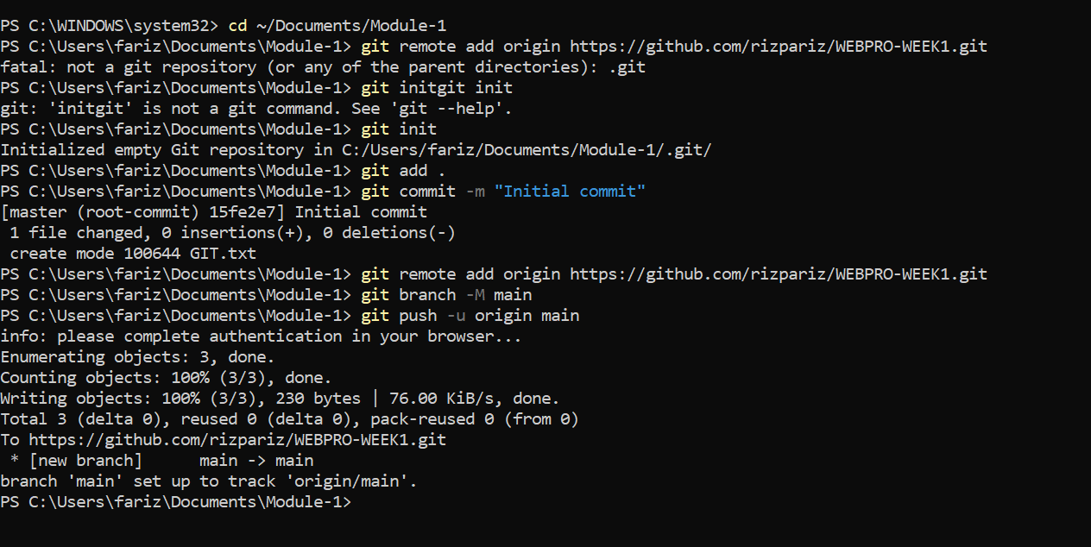
Hasil Commit
